Steps To Properly Use and Run The Project

LetZgo

* The Project is in .Apk extension and can only be ran on Android Devices having ARM Chipsets.
* First Step is to install the application on your android smartphone with SDK 21 (Android 5.0+) or Greater.



* Click On the icon which will be as:
* You will be shown with a Splash screen and Then comes the Home Page for LetZgo. There will be 4 Activities To use i.e. **LetZgo, LetZPark, SmartMap, Lost**

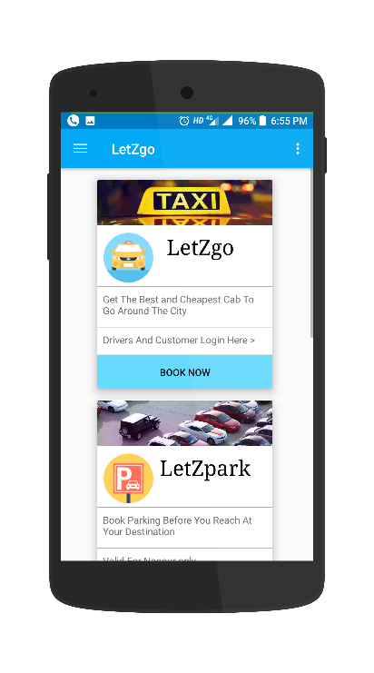

**LetZgo** Usage as Follows:

* Click on LetZgo on Home and you will be taken to LetZgo there will be 2 tabs Driver And Customer. Swipe to any section and you will get like activites like these:

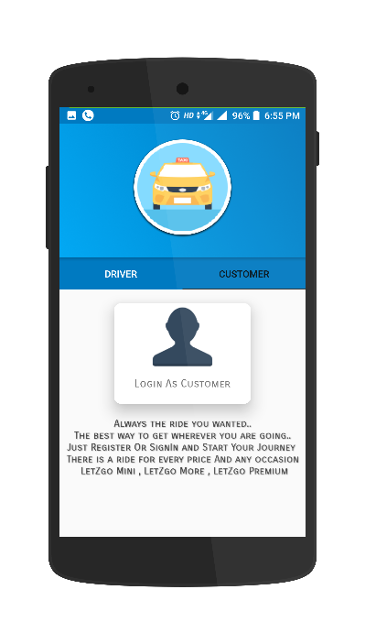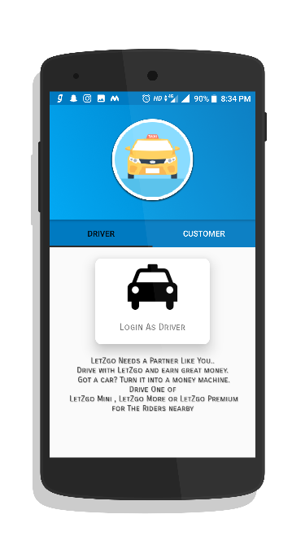

Customer Login Tab

Driver Login Tab

* For Driver as well as Customer Logins : Enter Email and Password
* 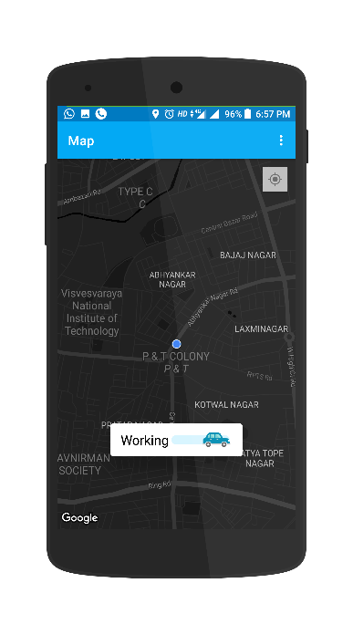 For Driver to Work Over: First You need the Phones Location as well as Internet Connection Permissions should be turned ON. After that Just Turn On the WORKING Switch on and you will be Zoomed to Your Location as :
* The 3 Dot menu will help you to setup the Drivers Name , Phone , Type of Service & Phone Number
* 3 Dot Menu Will Also Contain The Logout and Ride History Buttons/Menus
* The Customer Should be simultaneously be active on the app on the customer side (Logged in)
* For Customer: As Said all The permissions should be already turned ON.As Soon as You are logged in you will be on the CustomerMap and you will get page similar to down below. Here there will be Location Search box, Service Selection RadioButton ,Call Driver Button , Services Are **LetZgo Mini , LetZgo More , LetZgo Premium**
* Go to the Settings From 3 Dot menu and You Can Set The Settings as : Profile Photo, Name, Phone Number The Driver And Customer Settings are as Shown Below:

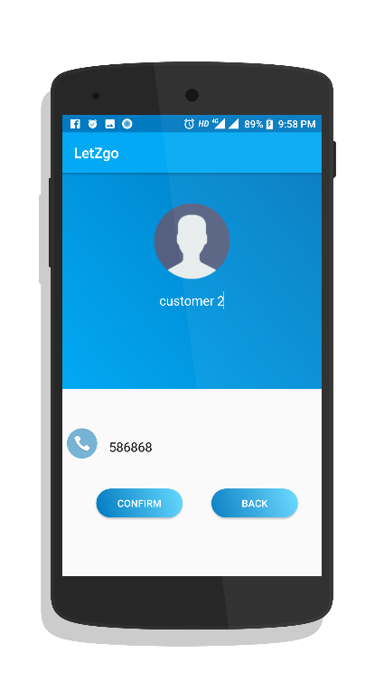

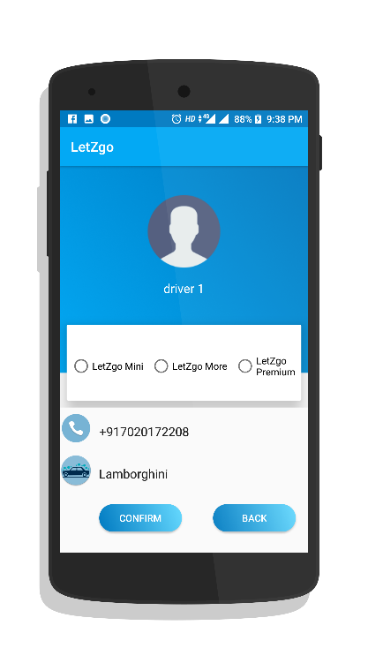

Customer Settings

Driver Settings

* For Calling the LetZgo Both Users Should be Active. On Drivers app when settings are setup and the switch is ON & Working the Customer Can Select the Preferred Service
* For the Instance If the Driver selects his service As LetZgo Mini And there is only 1 Driver and 1 Customer the Customer has to select LetZgo Mini.
* On Customer side just Enter the location where you want to go select the service as of the Driver and Click on The Call LetZgo button (After All the Things Setup in The Customer settings Page [Driver: Set Driver Settings])
* As You Click On The Call LetZgo button Both The User and The Driver will get Prompts of Each other information Containing Location(LATLONG) , Distance , Destination , Name, Phone, Profile Picture.
* The REAL TIME FIREBASE DATABASE will be updated on every activity you perform.

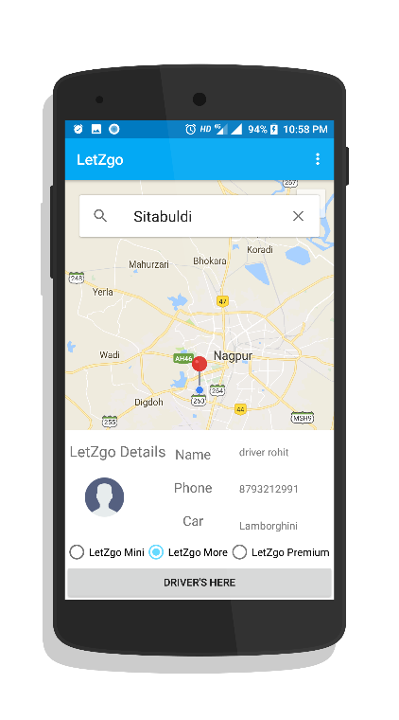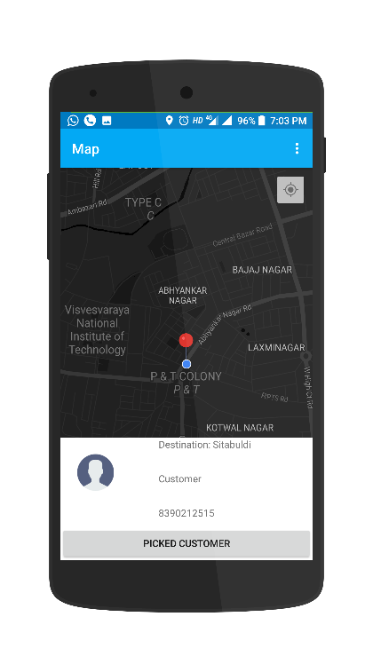

Driver Side Prompt

Customer Side Prompt

* The Drive is to be completed as the customer reaches the Destination The Drive History will be Shown in History section of 3 Dot menu.

**LetZPark** Usage As Follows:

* On Home Activity Click on the LetZPark Section and You Will be taken to the 1st LetZPark page
* On the First Page Select The AREA & TYPE OF VEHICLE you are having and plan book the parking for. Select the area you want to go from the DROPDOWN as well as the Type of Vehicle from Another DROPDOWN. Example is shown below:

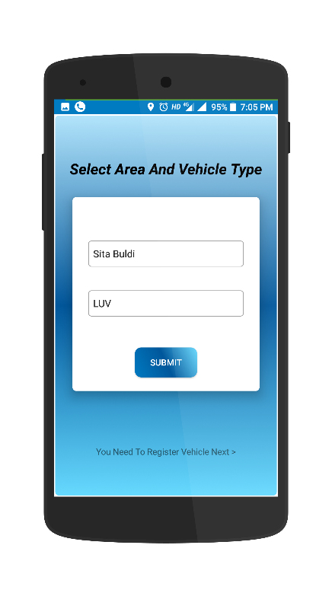

Area &Type selection

* Click on SUBMIT. Then there will be a Vehicle Registration Form You Have to Mandatorily fill all the Details there. The Registration Page Will look like:

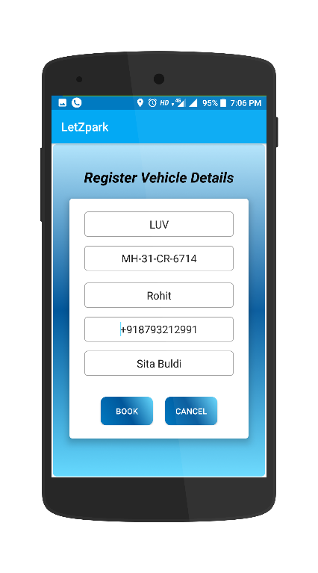

Vehicle Registration Page

* Click on NEXT and then select SLOTS which are available. Slot availability can Change during the time of parking but a parking will be assured by LetZPark assistant.
* The Selection of Slot Can be Done By clicking on Any of the Slot on Slot Activity and you can also reselect your slot if you desire to change the slot. Selection will be shown in RED color. Each Area/Layout will have its own different slots dependent on the Space.
* Area Selection and the Slot Selected Will be Shown Before You click next.
* 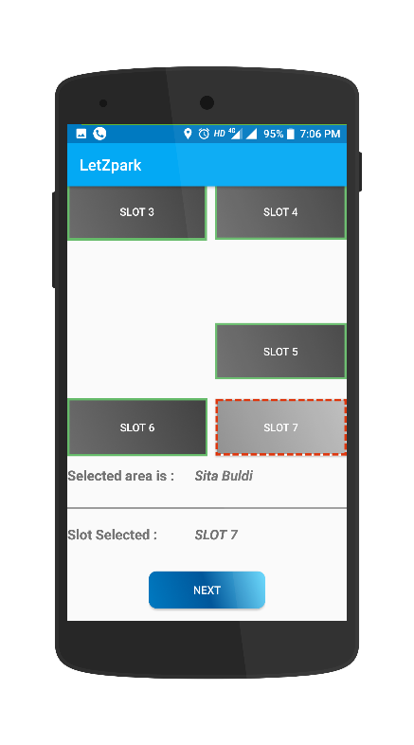Select the time you want to park 1st is the time you want to park from and 2nd is the time till when you want to park your vehicle. TimePickerDialog will help you to do so. These Steps are shown below:

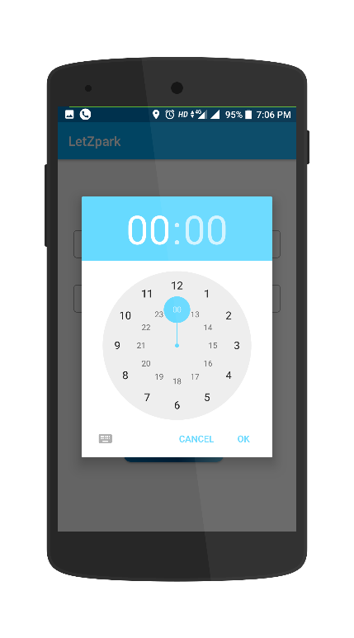

TimePickerDialog Set Time (From to)

Slot Selection

* Click on next After selecting time and you will get all the details you entered for parking

Here if you click on confirm booking the SMS will be sent to the parking assistant and your slot will be booked for the time period you stated. You will be charged by the carrier for the SMS charges.

* 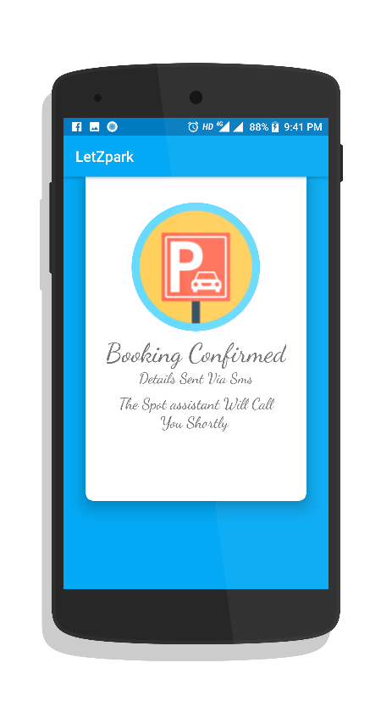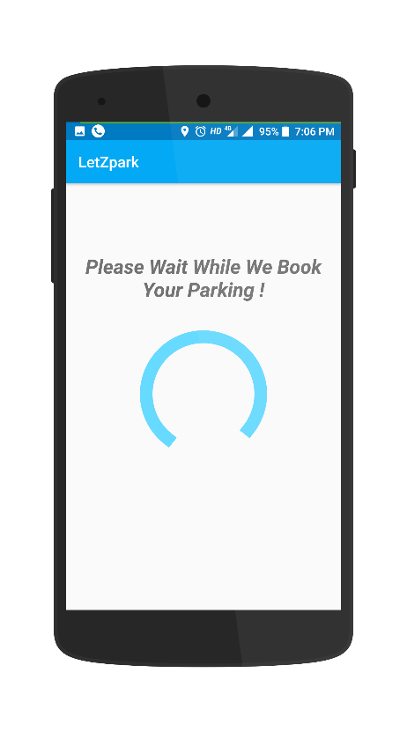The Booking will be done and you will see this Screen as shown:

**SmartMap** Usage as Follows:

* Scroll down on the Home activity and select SmartMap This will open a Activity having map and a Pullover CardView
* The maps shows your location and if you pullover the panel you will get several options and fast access actions.
* You can navigate , search HOSPITALS, RESTRAUNTS, SCHOOLS,PLACES.
* After you click on the options in the cardview you will get several Pointers Showing locations. You can navigate to the place by clicking on the pointer and dragging it a little bit and then click on TO in the pull over cardview.
* 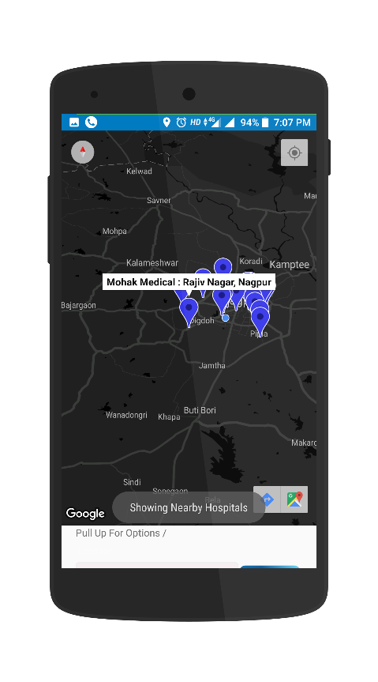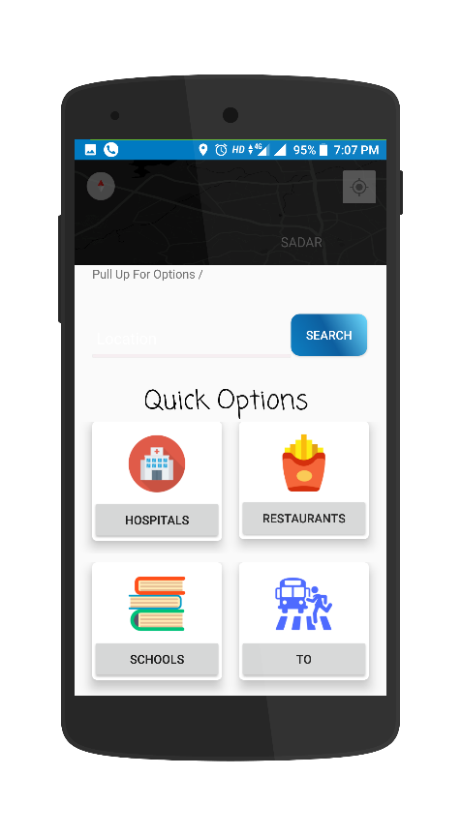The Example is Shown Below:

Quick Pullover Cardview

Hospitals Nearby Shown

Area Search

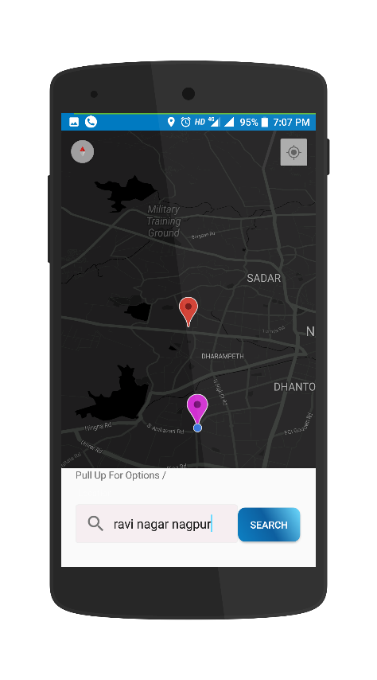

**Lost** Usage As Follows:

* Scroll to bottom on The Home Page and You will find Lost option.
* The only useful use of the LOST is that you can lookup to your current location and get out from there if you are totally lost somewhere you don’t know.